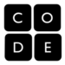
Did you enjoy the Hour of Code?
We hope you will continue coding and learning about Computer Science! Here are a few ideas:

On the iPad
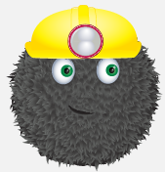 | - Kodable: Learn problem solving and programming basics. No reading required. Great for kids ages 5+.  - Free Kodable app: https://itunes.apple.com/us/app/kodable/id577673067?mt=8  - Download the Learning Guide: http://www.surfscore.com/
- Hopscotch: Learn programming basics with this visual programming language while building games and apps. Great for kids ages 8+.
  - Free Hopscotch app: https://itunes.apple.com/us/app/hopscotch-coding-for-kids/id617098629
  - Hopscotch Hour of Code video: http://www.youtube.com/watch?v=UH5CESyZ7So
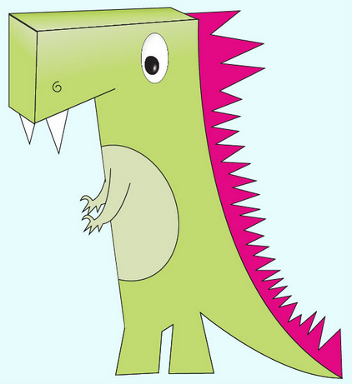 | - Daisy the Dinosaur: Another great visual programming language. Great for kids ages 8+.  - Free Daisy the Dinosaur app: https://itunes.apple.com/us/app/daisy-the-dinosaur/id490514278

On a Computer
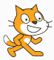 | - Scratch: Create stories, games, and animations using this visual programming language. Great for kids ages 8+.  - Get started by working along with the tutorial at http://scratch.mit.edu/projects/editor/?tip_bar=getStarted
- Alice: Create stories, games, and animations using this visual programming language. Great for middle school and high school students.
  - Get started at http://www.alice.org/HourOfCode/introduction.html
  - Go further with the full version of Alice at http://www.alice.org/index.php

No Computer Required!
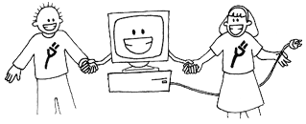 | - Computer Science Unplugged: Free learning games and puzzles that use cards, string, crayons, and lots of running around. Great for all ages. http://csunplugged.org/

Learn Even More
- Beyond One Hour of Code: http://csedweek.org/learn/beyond and http://code.org/
- 7th and 8th grade students can sign up for the Instructional Technology Applications course, which includes a unit on Scratch programming.
- 9th through 12th grade students can sign up for Computer Science I and AP Computer Science II, in which students learn to program using Alice and Java.

